Day 1 - Project Initiation & Stakeholder Discovery
Largence LegalTech Platform Optimisation & Digital Legal Workflow Transformation
1.Meeting Overview
Date: Saturday, 8th August 2026
Time: 3:00 PM - 4:00 PM (UK Time)
Duration: 1 Hour
Facilitator: BA Lead
Attendees: Group 4 BA’s
· Project Kickoff & Platform Overview: The session began with introductions, project objectives, and an overview of the Largence LegalTech platform presented by the Product Team.
· Stakeholder Discovery & Mapping: Stakeholder identification workshop, followed by stakeholder mapping and RACI model review to define roles and responsibilities.
· Discovery Plan & Interview Preparation: Discovery plan, scheduled stakeholder interviews, and prepared for requirements elicitation activities.
· Sign-off & Next Steps: The session concluded with discovery plan sign-off, agreement on next steps, and a Q&A session.

2.Key Challenges
Legal teams continue to struggle with manual drafting, disconnected collaboration tools, and email-based reviews. As organisations operate across multiple jurisdictions, they face mounting pressure to produce documents faster while ensuring accuracy, regulatory compliance, and operational efficiency.
Process Inefficiencies: Repetitive drafting activities, slow review cycles and manual approval workflows create significant delays and administrative burden.
Inconsistent Quality: Different users apply different templates and drafting approaches, leading to inconsistent document quality and increased review effort.
Limited Collaboration Visibility: Unknown document ownership, conflicting versions, and slow review cycles hinder effective teamwork and decision-making.
Compliance Complexity: Legal teams must navigate multiple jurisdictions, changing regulations, and organisation-specific policies, increasing risk and administrative overhead.
Stakeholder Misalignment: Lawyers prioritise accuracy and speed, compliance teams focus on regulatory assurance, businesses demand cost and turnaround efficiency, and product teams need adoption and scalability.

3.Objectives
This business analysis engagement aims to optimise Largence's LegalTech platform by improving legal workflows, defining product requirements, enhancing user journeys, strengthening compliance processes, and prioritising product capabilities.
- Objective 1 - Legal Drafting Workflow Analysis: Analyse current drafting journeys to identify inefficiencies and improvement opportunities.
- Objective 2 - Jurisdiction Compliance Requirements: Understand compliance needs across regions and document regulatory variations.
- Objective 3 - Template Marketplace Improvement: Define requirements for better legal template discovery and management.
- Objective 4 - Stakeholder Analysis: Understand competing stakeholder needs and build an engagement strategy.
- Objective 5 - Legal Operations KPI Framework: Create measurable indicators for drafting efficiency and compliance effectiveness.
- Objective 6 - User Onboarding Optimisation: Improve how new users achieve value on the platform.
- Objective 7 - AI Drafting Experience Optimisation: Improve user interaction with AI-generated documents and reduce abandonment.

4.Expected Outcomes
Operational efficiency will improve through reduced document turnaround times, lower administrative workloads, and increased productivity. Document quality will become more consistent across users. Platform adoption will increase, driving user satisfaction and retention. Strategic planning will become easier with clear priorities and validated user insights.
Key Deliverables: Stakeholder register and RACI model, As-Is and To-Be process maps, user journey maps, prioritised requirements backlog with user stories and acceptance criteria, compliance requirements specification, legal operations KPI framework and a BA recommendation report with a product improvement roadmap.
Together, these outcomes will move Largence from fragmented, manual legal workflows toward a governed, data-informed product roadmap that balances competing stakeholder needs with technical feasibility and business value.

5. Stakeholder Register
# | Stakeholder | Role | Department | Influence | Interest | Engagement Strategy
1 | Product Owner | Product Management | Product | High | High | Weekly meetings, roadmap alignment
2 | Product Manager | Product Management | Product | High | High | Weekly meetings, backlog prioritisation
3 | Lead Legal SME | Legal Expert | Legal | High | High | Daily consultation, requirements validation
4 | Legal SME (UK) | Legal Expert | Legal | Medium | High | Weekly workshops, compliance input
5 | Legal SME (EU) | Legal Expert | Legal | Medium | High | Weekly workshops, compliance input
6 | Legal SME (APAC) | Legal Expert | Legal | Medium | High | Weekly workshops, compliance input
7 | Engineering Lead | Development | Engineering | High | Medium | Daily stand-ups, technical feasibility
8 | QA Lead | Quality Assurance | Engineering | Medium | Medium | UAT planning, testing support
9 | Compliance Officer | Compliance | Legal | High | High | Compliance specification, validation
10 | Customer Success Lead | Customer Support | Customer Success | Medium | High | User feedback, adoption insights
11 | End User (Law Firm) | Legal Professional | External | Low | High | Feedback sessions, user testing
12 | End User (Corporate Legal) | Legal Professional | External | Low | High | Feedback sessions, user testing
13 | End User (Startup) | Legal Professional | External | Low | High | Feedback sessions, user testing
14 | End User (Compliance Team) | Compliance Professional | External | Low | High | Feedback sessions, user testing
15 | Business Analyst | BA | BA | Medium | High | Day-to-day delivery, documentation

6.Power/ Interest Grid
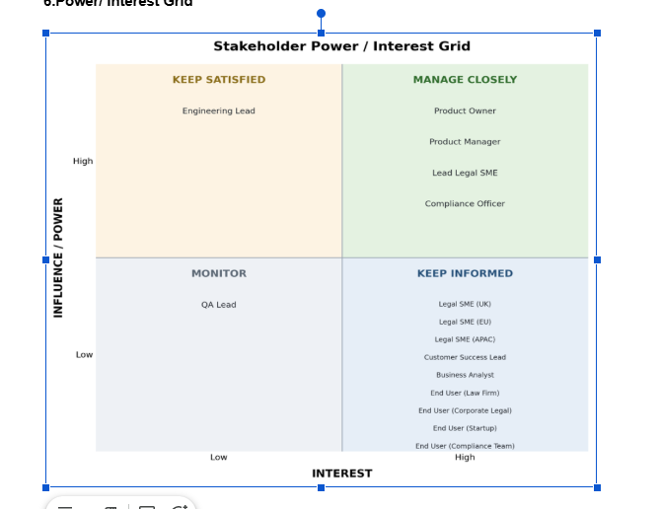

7.RACI Matrix
Roles and responsibilities by activity

Activity | Product Team | BA | Legal SMEs | Engineering
Define Requirements | A | R | C | C
Process Mapping | C | R | C | I
Solution Validation | A | R | C | R
User Story Creation | A | R | C | C
Compliance Review | C | C | R | I
UAT Execution | A | C | C | R
Stakeholder Engagement | C | R | C | I
KPI Definition | A | R | C | C

8. BA Discovery Plan
Day | Activity | Deliverable
Day 1 | Project Initiation & Stakeholder Discovery | Stakeholder register & BA discovery plan
Day 2 | Legal Document Drafting Workflow Discovery | As-Is legal drafting process map
Day 3 | Stakeholder Requirements Elicitation Workshop | Initial business requirements catalogue
Day 4 | User Journey Analysis for Platform Adoption | User journey map
Day 5 | Compliance Workflow Requirements Analysis | Compliance requirements specification

As-Is Largence legal drafting process map
1. Business or client identifies a need for a legal document.
2. Request is sent to the legal team.
3. Lawyer receives and reviews the request.
4. Lawyer determines the document type and requirements.
5. Lawyer searches for an existing template.
6. Lawyer searches previous documents for suitable clauses.
7. Lawyer selects the most relevant document/template.
8. Lawyer decides whether it can be reused.
9. Suitable templates available?
10. YES- Adapt existing template
11. NO- Start drafting from scratch or beginning
12. Lawyer opens the template/document.
13. Lawyer modifies the document manually.
14. Lawyer updates clauses.
15. Lawyer reviews the initial draft.
16. Lawyer saves the document.
17. Draft is sent to the relevant reviewer.
18. Compliance team checks the document.
19. Reviewer checks applicable jurisdictional requirements.
20. Identification potential compliance issues?
21. If YES -Return document to lawyer for amendment.
22. If NO -Continue to stakeholder review.
23. Stakeholders review the document.
24. Stakeholders provide comments or amendments.
25. Lawyer incorporates feedback.
26. Revised document is circulated
27. Further changes required?
28. YES - Return to drafting/review.
29. NO - Proceed to approval.
30. Final reviews are circulated.
31. Required stakeholders provide approval.
32. Lawyer confirms all required approvals have been received.
33. All approval received?
34. NO -Follow up with outstanding stakeholder.
35. YES - Proceed to finalisation.
36. Final document is prepared.
37. Required Stakeholder sign the document.
38. Final version is confirmed.
39. Document status is updated.
40. Document is stored and tracked manually
41. End Process
AS-IS legal process map

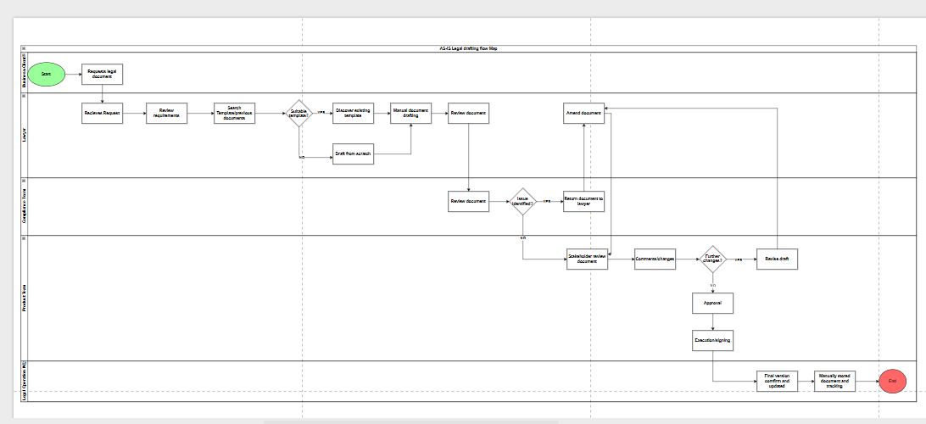
LARGENCE STAKEHOLDER REQUIREMENTS ELICITATION WORKSHOP
Workshop Purpose and Focus
This workshop will attempt to bring key stakeholders together in order to establish an understanding of the business challenges, drawing out the initial requirements to help guide analysis and product development.
The following will be the focus of the workshop
· Understanding the current business challenges surrounding legal document management.
· Establishing the desired business outcomes for Largence.
· Identifying stakeholder needs and expectations.
· Defining high-level business requirements.
· Identifying jurisdictional considerations across the UK and EU.
· Establishing priorities for the initial product scope.
· Identifying areas requiring further investigation.
Workshop Participants
Facilitator(s): Appointed member from the project or BA Team
Stakeholders | Primary Contribution
Product Owner | Business priorities, product value, requirements prioritisation
Product Manager | Product vision, strategy, roadmap and business objectives
Lead Legal SME | Overall legal processes, professional standards and governance
Legal SME (UK) | UK legal and compliance requirements
Legal SME (EU) | EU legal and compliance requirements
Engineering Lead | Technical feasibility, constraints and implementation considerations

Proposed Workshop Agenda
Proposed Duration: 2 hours
Time/Duration | Session | Purpose
10 mins | Introduction and Objectives | Establish workshop purpose, scope and expected outputs
15 mins | Business Problem Review | Validate the identified business challenges
20 mins | Business Outcomes | Establish what Largence needs to achieve for the business
25 mins | Document Lifecycle Discussion | Explore drafting, review, collaboration, approval and execution needs
20 mins | AI, Compliance & Governance | Explore AI-assisted processes, jurisdictional compliance and human oversight
15 mins | Requirement Identification | Capture and consolidate business requirements
10 mins | Prioritisation | Prioritise requirements using MoSCoW
5 mins | Summary & Next Steps | Confirm decisions, assumptions and outstanding questions

Elicitation Questions
Business Challenges: This is to help validate the identified challenges
· How significantly does manual drafting dependency affect legal teams?
· Where does inconsistent document quality currently arise?
· What visibility is currently missing during collaboration?
· Which aspects of UK and EU compliance create the greatest difficulty?
· Where does fragmentation occur across the document lifecycle?
AI Assisted Drafting
· Which types of legal documents should Largence initially support?
· What drafting activities should AI assist with?
· What level of human review should be required before AI-generated content is used?
· What controls are required around AI-generated content?
· What would constitute an acceptable level of AI assistance?
Compliance
· Who needs to collaborate on a legal document?
· What activities should stakeholders be able to perform?
· What visibility should users have over revisions, comments and approvals?
· How should disagreements or changes be managed?
Document Lifecycle
· What information needs to be captured throughout the document lifecycle?
· What constitutes a completed approval?
· What constitutes execution?
· How should document history and revisions be maintained?
· What information needs to remain available after execution?
Largence LegalTech Platform Optimisation
Elicitation Questions – Stakeholder Interview Feedback
Purpose: To validate identified business challenges, understand AI-assisted drafting expectations, define compliance collaboration needs, and capture document lifecycle requirements.
1. Business Challenges
1. How significantly does manual drafting dependency affect legal teams?
Stakeholder Response:
Manual drafting dependency has a significant impact on legal team productivity because lawyers spend considerable time completing repetitive activities rather than focusing on higher-value legal work.
The main impacts include:
Reduced Productivity
Legal professionals spend time on:
- Searching for previous agreements
- Copying content from existing documents
- Updating standard clauses
- Formatting documents
- Checking repetitive information
Longer Turnaround Times
Manual drafting increases the time required to:
- Produce first drafts
- Complete revisions
- Finalise approvals
This creates pressure when customers expect faster legal support.
Increased Risk of Human Error
Manual processes increase the likelihood of:
- Missing clauses
- Incorrect information
- Outdated wording
- Inconsistent formatting
Reduced Scalability
As document volumes increase, legal teams require additional resources rather than improving efficiency.
AI-assisted drafting should reduce repetitive work while allowing lawyers to maintain control over legal decisions.
2. Where does inconsistent document quality currently arise?
Stakeholder Response:
Inconsistent document quality occurs mainly because legal teams rely heavily on individual knowledge and different working methods.
Key causes include:
Template Variation
Different teams may use:
- Different templates
- Old versions
- Unapproved documents
Individual Drafting Approaches
Different lawyers may:
- Structure documents differently
- Use different clauses
- Apply different review standards
Knowledge Dependency
Important legal knowledge may exist only within specific individuals.
Lack of Standardised Controls
There may not always be:
- Mandatory checks
- Approved clause libraries
- Document validation rules
A centralised template and clause management approach would improve consistency.
3. What visibility is currently missing during collaboration?
Stakeholder Response:
The biggest visibility gaps relate to ownership, progress and responsibility.
Users often lack visibility into:
Document Status
Users need to know:
- Is the document being drafted?
- Is it under review?
- Is approval pending?
- Is action required?
Ownership
Users need clarity on:
- Who owns the next action?
- Who is responsible for approval?
- Who is delaying progress?
Review Activity
Users need visibility of:
- Comments submitted
- Changes made
- Outstanding feedback
- Completed reviews
- Approval Progress
Users need to understand:
- Who has approved
- Who is still pending
- What happens next
4. Which aspects of UK and EU compliance create the greatest difficulty?
Stakeholder Response:
The greatest challenges relate to maintaining consistency across different regulatory environments.
Key difficulties include:
Data Protection Requirements
Challenges include:
- Handling personal information
- Maintaining appropriate access controls
- Managing data retention requirements
Jurisdiction Differences
Different regions may require:
- Different clauses
- Different contract wording
- Different approval processes
Regulatory Changes
Compliance teams must continuously monitor:
- New regulations
- Policy updates
- Internal governance changes
Audit Requirements
Organisations need evidence of:
- Reviews performed
- Approvals completed
- Decisions made
5. Where does fragmentation occur across the document lifecycle?
Stakeholder Response:
Fragmentation occurs because different stages of the lifecycle often happen in different tools.
Examples include:
Request Stage
Requests may arrive through:
- Email
- Teams
- Internal systems
Drafting Stage
Documents may move between:
- Largence
- Microsoft Word
- Shared folders
Review Stage
Feedback may occur through:
- Comments
- Emails
- Meetings
Approval Stage
Approvals may happen outside the platform.
Storage Stage
Final documents may exist in multiple locations.
The main requirement is creating one connected document lifecycle from request to execution.
2. AI Assisted Drafting
1. Which types of legal documents should Largence initially support?
Stakeholder Response:
AI-assisted drafting should initially focus on high-volume, lower-risk documents where patterns and approved structures already exist.
Priority document types include:
Commercial Agreements
Examples:
- Supplier agreements
- Service agreements
- Partnership agreements
Confidentiality Agreements
Examples:
- NDAs
- Confidentiality clauses
Employment Documents
Examples:
- Employment agreements
- Contractor agreements
Data Protection Documents
Examples:
- Data processing agreements
- Privacy-related documents
Standard Corporate Documents
Examples:
- Standard legal letters
- Internal agreements
Complex or highly specialised documents should initially remain human-led.
2. What drafting activities should AI assist with?
Stakeholder Response:
AI should support activities that reduce repetitive work.
Potential AI assistance includes:
First Draft Generation
AI can create an initial draft based on:
- Approved templates
- User information
- Jurisdiction requirements
Clause Suggestions
AI can recommend:
- Relevant clauses
- Alternative wording
- Missing provisions
Document Review
AI can identify:
- Missing sections
- Inconsistencies
- Potential risks
Document Summarisation
AI can generate:
- Key points
- Obligations
- Important changes
Formatting Support
AI can assist with:
- Structure
- Formatting consistency
- Document completion
3. What level of human review should be required before AI-generated content is used?
Stakeholder Response:
Human review should always be required before AI-generated content becomes part of a final legal document.
The level of review should depend on document risk.
Low-Risk Documents
Require:
- Lawyer review
- Confirmation of accuracy
Medium-Risk Documents
Require:
- Detailed legal review
- Clause validation
- Compliance checks
High-Risk Documents
Require:
- Specialist legal review
- Formal approval
- Full audit trail
AI should support lawyers, not replace professional judgement.
4. What controls are required around AI-generated content?
Stakeholder Response:
Required controls include:
Transparency Controls
Users should understand:
- Which content was AI-generated
- What changes AI suggested
- Why suggestions were made
Approval Controls
AI-generated content should require:
- Human validation
- Appropriate approval workflow
Security Controls
Requirements include:
- Protection of confidential information
- Controlled AI data usage
- Access management
Audit Controls
The system should record:
- AI usage
- Generated content
- Accepted/rejected suggestions
- User decisions
5. What would constitute an acceptable level of AI assistance?
Stakeholder Response:
An acceptable level of AI assistance would be where AI reduces administrative effort while maintaining legal quality.
Success would mean AI can:
- Create reliable first drafts
- Identify potential issues
- Suggest relevant clauses
- Reduce review time
while lawyers maintain:
- Final judgement
- Approval responsibility
- Risk assessment
The goal is increased productivity, not replacing legal expertise.
3. Compliance & Collaboration
1. Who needs to collaborate on a legal document?
Stakeholder Response:
Depending on the document type, collaboration may involve:
Internal Legal Team
- Drafting lawyer
- Reviewing lawyer
- Legal manager
Compliance Team
For:
- Regulatory review
- Risk assessment
Business Stakeholders
For:
- Commercial decisions
- Requirements clarification
External Parties
Including:
- Clients
- Suppliers
- Partners
- External legal advisors
2. What activities should stakeholders be able to perform?
Stakeholder Response:
Stakeholders should be able to:
Legal Users
- Create drafts
- Edit documents
- Review clauses
- Approve changes
Business Users
- Submit requests
- Provide information
- Review drafts
- Approve business terms
Compliance Users
- Perform checks
- Raise issues
- Approve compliance requirements
External Users
- Review documents
- Provide comments
- Approve agreed changes
3. What visibility should users have over revisions, comments and approvals?
Stakeholder Response:
Users should have visibility into:
Revision History
Including:
- Previous versions
- Changes made
- Person responsible
- Date/times
Comments
Including:
- Open comments
- Resolved comments
- Comment ownership
Approval Status
Including:
- Approved users
- Pending users
- Rejected items
- Required actions
4. How should disagreements or changes be managed?
Stakeholder Response:
Disagreements should be managed through a controlled collaboration process.
The platform should support:
- Comment discussions
- Change requests
- Issue ownership
- Escalation routes
- Approval checkpoints
Major changes should require:
- Documentation
- Reason capture
- Appropriate approval
4. Document Lifecycle
1. What information needs to be captured throughout the document lifecycle?
Stakeholder Response:
The platform should capture information from creation through execution.
Required information includes:
Request Information
- Requestor
- Business purpose
- Document type
- Deadline
- Priority
Drafting Information
- Template used
- Clauses selected
- Authors
- AI involvement
Review Information
- Reviewers
- Comments
- Changes
- Decisions
Approval Information
- Approvers
- Dates
- Approval outcomes
Execution Information
- Signing parties
- Execution date
- Final document version
2. What constitutes a completed approval?
Stakeholder Response:
A completed approval means:
- The correct approver has reviewed the document
- Required comments have been resolved
- Approval decision has been recorded
- Approval date/time is captured
- Any required compliance checks are completed
Approval should not simply mean someone viewed the document.
3. What constitutes execution?
Stakeholder Response:
Execution means:
- All required approvals are complete
- Final version is confirmed
- Required parties have signed
- Signing evidence is stored
- Document status changes to completed
The executed version should become the official record.
4. How should document history and revisions be maintained?
Stakeholder Response:
Document history should include:
- Every version created
- Changes between versions
- User responsible
- Date/time
- Reason for changes
- Approval history
Previous versions should remain accessible but protected from unauthorised changes.
5. What information needs to remain available after execution?
Stakeholder Response:
After execution, the organisation should retain:
- Final signed document
- Complete audit trail
- Approval history
- Version history
- Template used
- Compliance checks completed
- Key dates
- Renewal or expiry information
- Responsible owners
This information supports:
- Future negotiations
- Audits
- Compliance reviews
- Contract management

Initial Business Requirements Catalogue
This catalogue represents an initial requirement which is made up from the identified current challenges. Hence, it should be treated as a guide for setting up the business requirement catalogue during the workshop.
ID | Business Requirement | Business Rationale | Priority
BR-001 | Largence shall provide a centralised workspace for managing the legal document lifecycle. | Address fragmented document management and improve visibility. | Must Have
BR-002 | Largence shall support AI-assisted creation and drafting of legal documents. | Reduce reliance on manual drafting and improve efficiency. | Must Have
BR-003 | Largence shall enable legal professionals to review documents within the platform. | Create a centralised review process and reduce fragmented workflows. | Must Have
BR-004 | Largence shall provide compliance support during document review. | Help legal professionals identify potential compliance issues. | Must Have
BR-005 | Largence shall support jurisdiction-specific compliance considerations. | Legal requirements may differ between jurisdictions. | Must Have
BR-006 | Largence shall support UK-specific compliance considerations. | Ensure the platform can accommodate UK legal requirements. | Must Have
BR-007 | Largence shall support EU-specific compliance considerations. | Ensure the platform can accommodate relevant EU legal requirements. | Must Have
BR-008 | Largence shall enable multiple stakeholders to collaborate on legal documents. | Improve collaboration and reduce disconnected review processes. | Must Have
BR-009 | Largence shall provide visibility of document revisions and changes. | Improve transparency and reduce uncertainty around document versions. | Must Have
BR-010 | Largence shall support reusable legal document templates. | Improve consistency and reduce repetitive drafting activities | Must Have
BR-011 | Largence shall enable standardised legal document structures to be maintained and reused. | Address inconsistent document quality. | Should Have
BR-012 | Largence shall maintain a history of document revisions. | Provide traceability throughout the document lifecycle. | Must Have
BR-013 | Largence shall track document approval status. | Provide visibility of where a document is within the approval process. | Must Have
BR-014 | Largence shall track document execution status. | Provide visibility of whether documents have been formally executed. | Must Have
BR-015 | Largence shall maintain a record of document lifecycle activity. | Support governance, traceability and accountability. | Should Have
BR-016 | Largence shall combine AI automation with appropriate human governance and oversight. | Ensure automation does not remove appropriate human control over legal work. | Must Have
BR-017 | Largence shall enable authorised stakeholders to contribute to document review and development. | Ensure relevant stakeholders can participate in the document lifecycle. | Must Have
BR-018 | Largence shall provide a consistent process for drafting, reviewing, collaborating on and executing legal documents. | Establish a standardised end-to-end legal document workflow. | Must Have

Link to User Journey Map:
https://www.figma.com/make/4SCP3f6IqqQESFPlCYonHZ/User-journey-map-for-Sarah?t=x10R0Hf2d20RdFOF-1

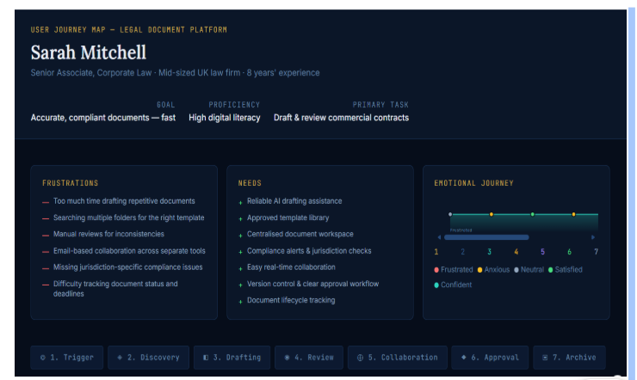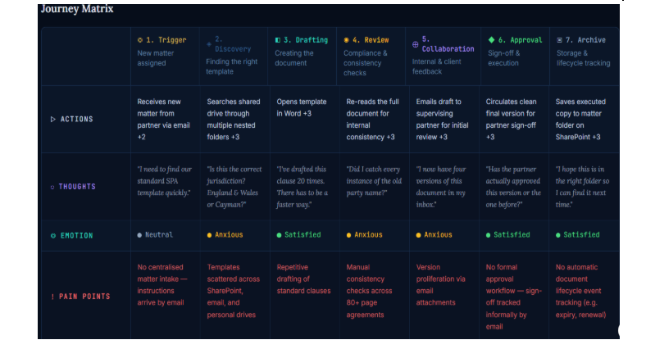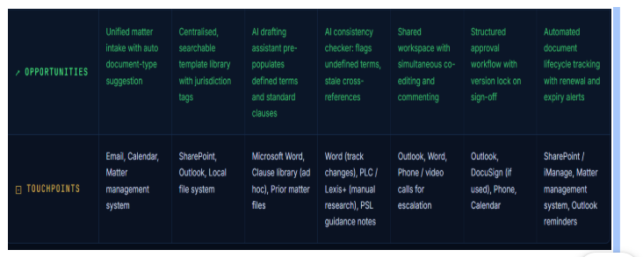

Alternative user journey map
Largence USER JOURNEY MAPPING.drawio

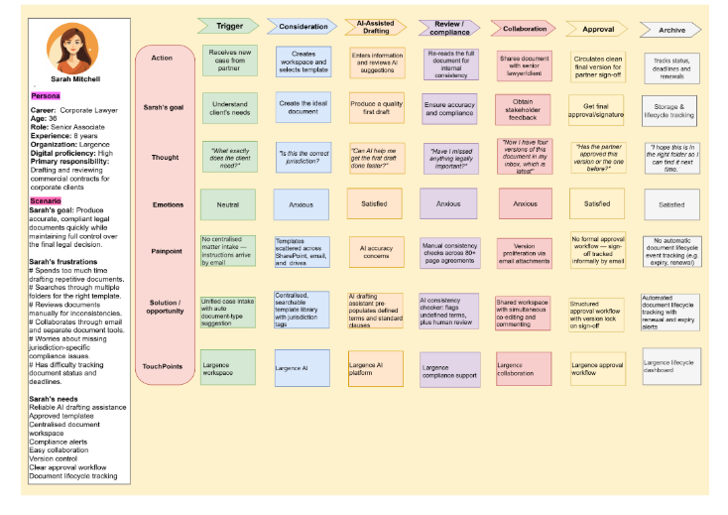
DAY 5 - Compliance Workflow Requirements Analysis
1. Compliance Requirements Specification
Purpose:
To define the requirements for ensuring that legal documents created on the Largence platform comply with applicable jurisdictional requirements, regulations and organisational policies.
Compliance Requirements
ID | Compliance Requirement | Priority
CR-01 | The system shall identify the applicable jurisdiction for each legal document. | Must Have
CR-02 | The system shall apply the relevant compliance rules based on the applicable jurisdiction. | Must Have
CR-03 | The system shall check documents against applicable compliance requirements. | Must Have
CR-04 | The system shall identify and highlight potential compliance issues. | Must Have
CR-05 | Lawyers shall be able to review identified compliance issues. | Must Have
CR-06 | Complex or unresolved compliance issues shall be escalated to an appropriate Compliance or Legal SME. | Must Have
CR-07 | The system shall allow authorised users to record compliance decisions. | Must Have
CR-08 | Mandatory compliance issues shall be resolved before final document approval. | Must Have
CR-09 | The system shall maintain an audit trail of compliance checks and decisions. | Must Have
CR-10 | Compliance rules shall be maintained and updated when requirements change. | Should Have
CR-11 | The system shall maintain the compliance status of each document. | Should Have
CR-12 | The system should provide compliance reporting and performance measures. | Should Have

Expected Compliance Workflow
Identify Jurisdiction → Apply Compliance Rules → Check Document → Identify Issues → Review/Resolve → Escalate if Required → Record Decision → Compliance Passed → Final Approval

https://drive.google.com/file/d/1mPBxFcxKunUhz1pn15fTnkYdfUEEvDKX/view?usp=drive_link
The specification reflects Largence's focus on jurisdiction-specific compliance and its human-in-the-loop governance approach.

2. Business Rules Catalogue
Purpose:
To define the mandatory rules that govern how compliance must operate within the Largence platform.
Rule ID | Business Rule
BR-01 | A legal document must have an identified jurisdiction before compliance checking can begin.
BR-02 | Compliance checks must use the rules applicable to the identified jurisdiction.
BR-03 | Every document must undergo the required compliance check before final approval.
BR-04 | Mandatory compliance failures must be resolved before a document can be approved.
BR-05 | Compliance issues that cannot be resolved by the document owner must be escalated to an appropriate Legal or Compliance SME.
BR-06 | Only authorised users may override a compliance warning or exception.
BR-07 | Every compliance override must have a documented reason.
BR-08 | Every compliance decision must be recorded against the relevant document.
BR-09 | Compliance decisions must be traceable to the relevant document version.
BR-10 | Changes to compliance rules must be controlled and recorded.
BR-11 | Where a material change is made to a document, compliance validation must be repeated where applicable.
BR-12 | Historical compliance records must be retained for audit and traceability purposes.

